Inside the file (and the folder it installs to) you will find examples, also attached in this mail.

To install (To global modules):

npm install -g node-red-contrib-icomox-parser-1.0.0.tgz

To uninstall

npm uninstall -g node-red-contrib-icomox-parser

To view installed packages (and the folder it is install to):

npm list -g --depth=0

Output:

​

Once the node is installed you will see it in NodeRed palette:

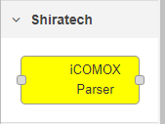

Same node is used for both incoming and outgoing messages

Cloud -> iCOMOX:

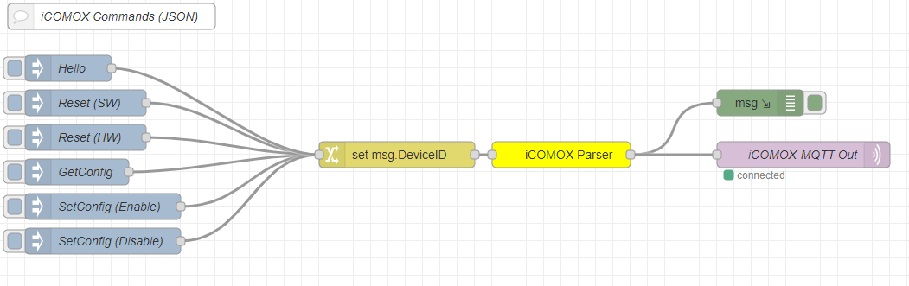

iCOMOX -> Cloud:



 